Delete anything that is NOT bold and add your replies. This Goal statement is more specific than the Smart Goals. Use the Smart Goals to Guide you to complete this goal statement. Use as many months as you need. This is timeline specific and more precise than the Smart Goals. Take your time and really think about how you will accomplish your Smart Goals by using the Goal Statement and the timeline guides below it. This will help your trainer and you achieve your Smart Goals for the rider and the horse.

Delete the above paragraph before saving and printing the final draft.

Goal Statement:
This may be a show Goal of a certain percentage to achieve in a test or It may be a trail goal of items that you may be having issues with. It can be combined with horse and rider achieving a goal.
Example: After training: I will ride out on the trails once a week with Fluffy and we will be able to stop on the trail easily. I will be more confident because of this increased willingness of Fluffy to stop.
Example: I will be able to perform a first level test to a 60% or above.

How you'll measure your progress:
- Specific things to accomplish goal:
* I will know this goal has been achieved because…..
- To achieve my goal, I will… * Watch videos, exercise using yoga techniques to increase core. I will take lessons and practice what I know on other horses. I will watch the training videos in the classroom, I will ask questions…
- Ride in Schooling shows and record scores and work on low points of the tests.
- Schedule Late season recognized shows when ready to do GP test.

I will achieve my goal by:
Month/ Year

Other items that will help achieve this Smart Goal
Fluffy will have front shoes put on in May.
Fluffy will be on Smartpak calm and smart back Colic

Timeline.

DATE HERE
Fluffy In training at Whispering Hills
Hill work/Consistent contact in bridle and responsiveness to aids.
Straightness and lightness in bridle
Neck rein focus
No rein stop (See horse smart Goals)
Rider- Planks, jogging inside. Stretching. Online education Youtube, subscription to Training. Lessons…

Month:
Horse :Continue training and fitness.
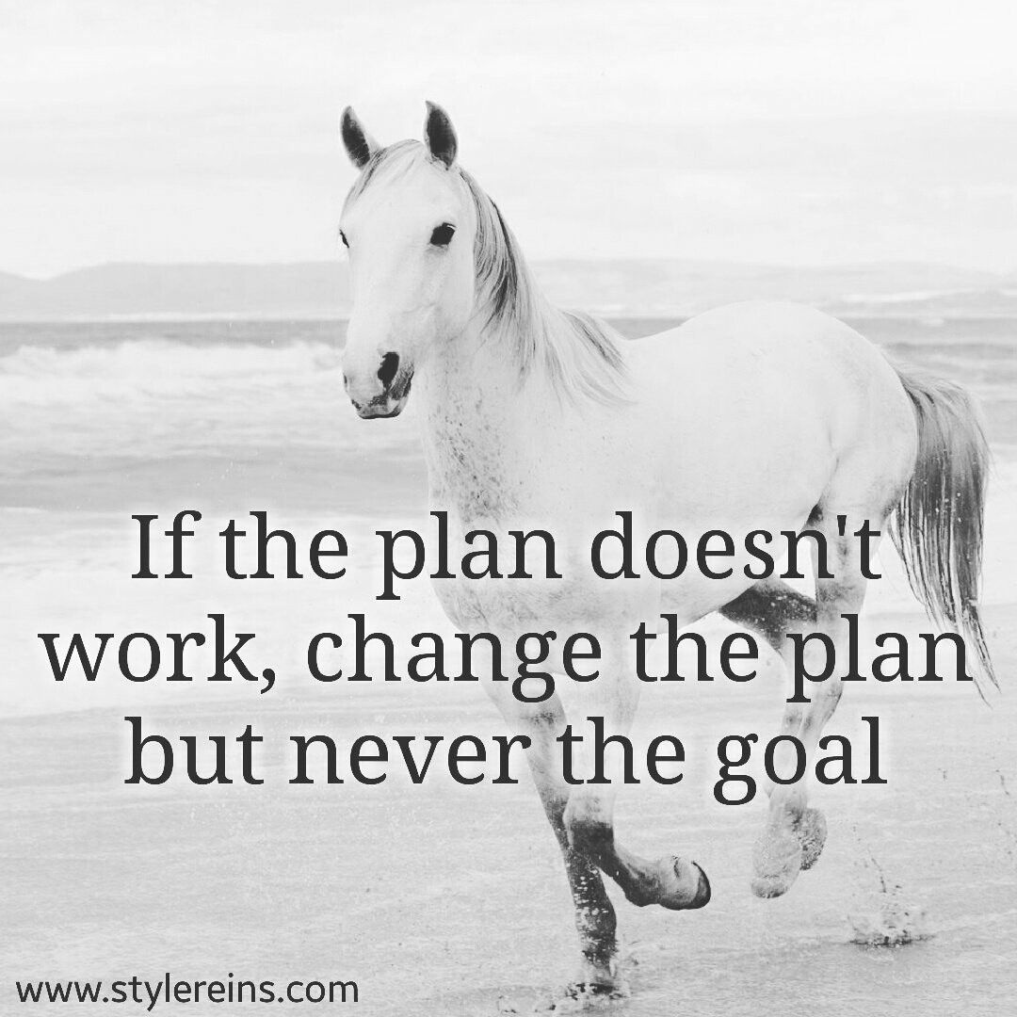
xxxxxxxxxxxx
Rider: X training Skiing, indoor running, indoor bike, practice test.
Education:

Next month:
Horse: Fitness and soundness.
specifics

More here…..

Month xxxxxxxxxxxxxxxxxxxxxxx
Month: xxxxxxxxxxxxxxxxxxx

